**Master Approver System**

CODING METRICES

**GROUP MEMBERS: SAMANTAK MITRA, SHUBHAM, SHUBHAM TRIPATHI, SMIT SANDIP SHAH, VISHWAS SAINI**

# **Software measurements**

The following list shows and explain in brief about the code metrics results that are calculated for our project:

* **Maintainability Index** - Calculates an index value between 0 and 100 that represents the relative ease of maintaining the code. A high value means better maintainability. Color coded ratings can be used to quickly identify trouble spots in your code. A green rating is between 20 and 100 and indicates that the code has good maintainability. A yellow rating is between 10 and 19 and indicates that the code is moderately maintainable. A red rating is a rating between 0 and 9 and indicates low maintainability.
* **Cyclomatic Complexity** - Measures the structural complexity of the code. It is created by calculating the number of different code paths in the flow of the program. A program that has complex control flow will require more tests to achieve good code coverage and will be less maintainable.
* **Depth of Inheritance** - Indicates the number of class definitions that extend to the root of the class hierarchy. The deeper the hierarchy the more difficult it might be to understand where particular methods and fields are defined or/and redefined.
* **Class Coupling** - Measures the coupling to unique classes through parameters, local variables, return types, method calls, generic or template instantiations, base classes, interface implementations, fields defined on external types, and attribute decoration. Good software design dictates that types and methods should have high cohesion and low coupling. High coupling indicates a design that is difficult to reuse and maintain because of its many interdependencies on other types.
* **Lines of Code** - Indicates the approximate number of lines in the code. The count is based on the IL code and is therefore not the exact number of lines in the source code file. A very high count might indicate that a type or method is trying to do too much work and should be split up. It might also indicate that the type or method might be hard to maintain.

# **Generated code**

Some software tools and compilers generate code that is added to a project and that the project developer either does not see or should not change. Mostly, Code Metrics ignores generated code when it calculates the metrics values. This enables the metrics values to reflect what the developer can see and change.

Code generated for Windows Forms is not ignored, because it is code that the developer can see and change.

**NOTE:**

DateTime object is also treated as a Class and hence Coupling value in classes with DateTime variables have extra coupling value than actually intended in the application.

Here we have used Visual Studio therefore code generated by Windows Forms is not ignored.

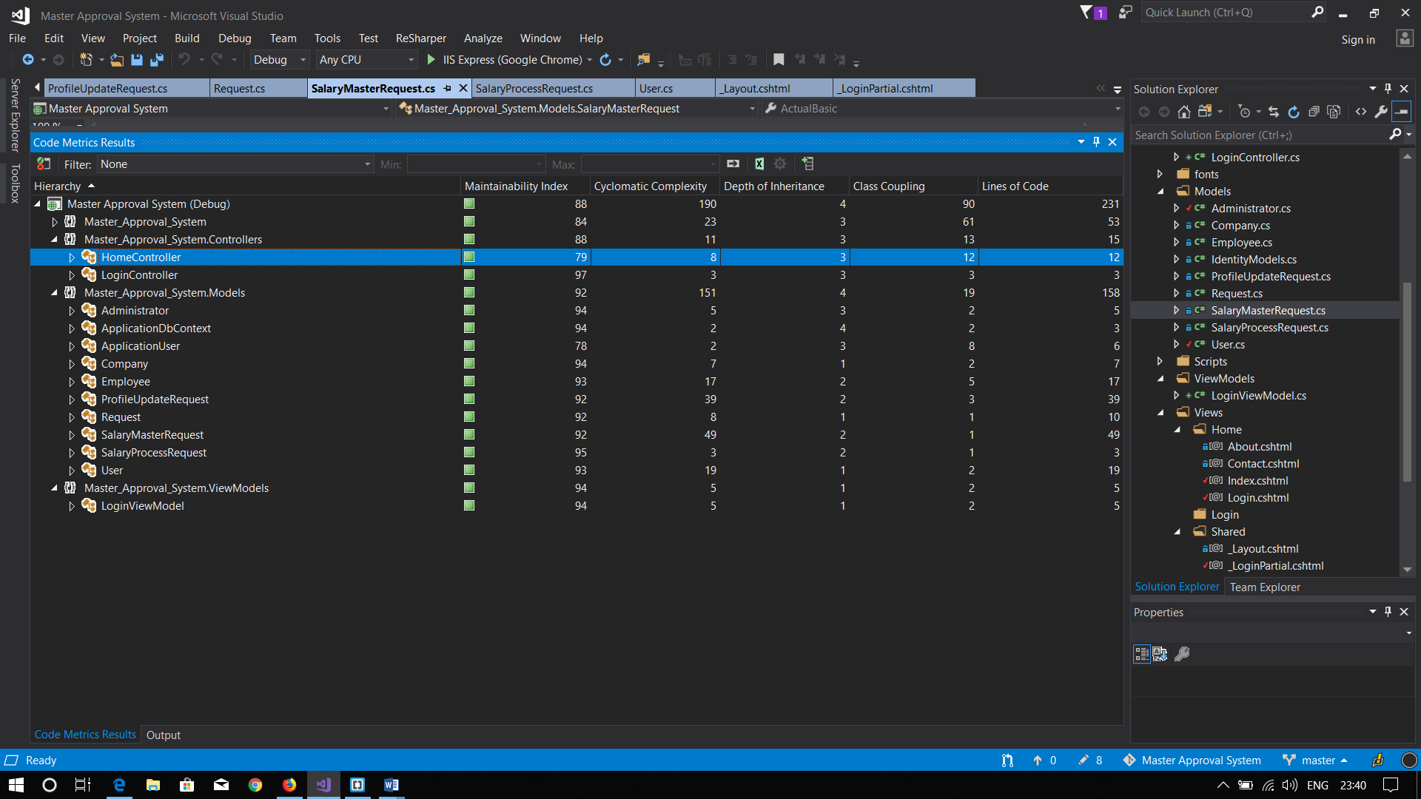**SCREENSHOTS OF THE ANALYSIS RUN IN VISUAL STUDIO 2017**

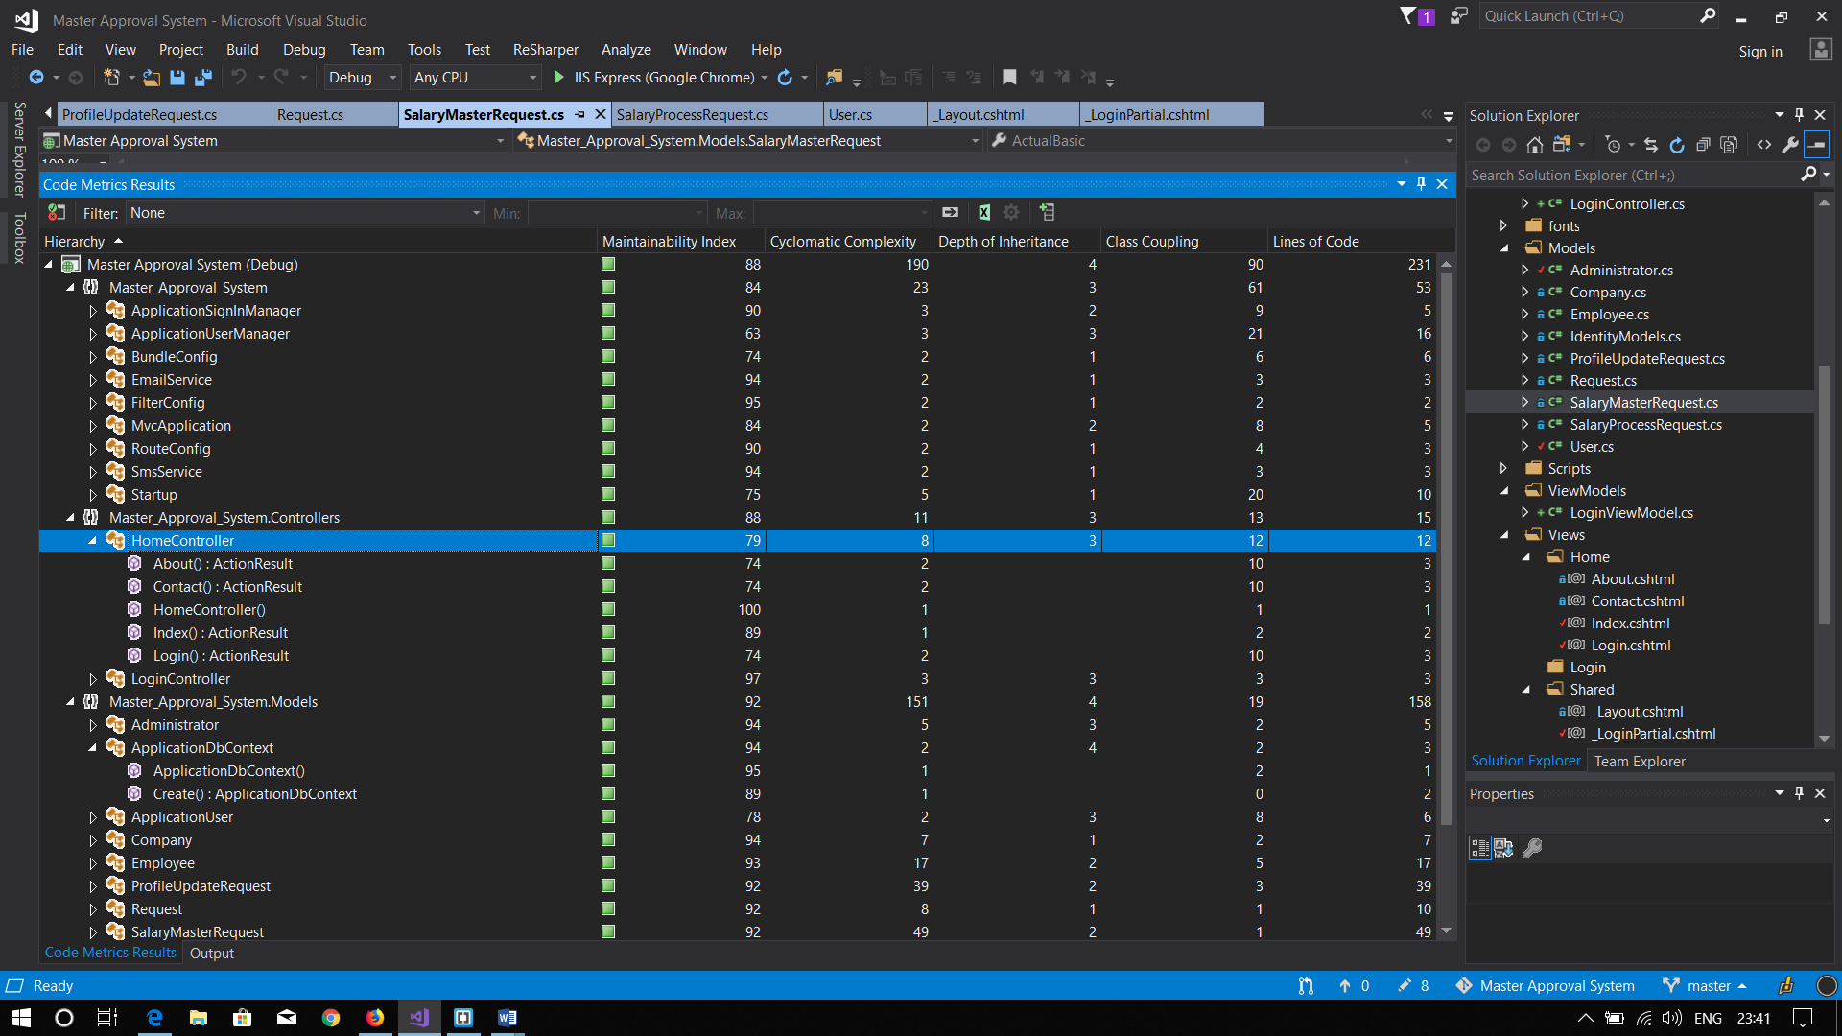

# **Coding Metrics (Detailed)**

|  |  |  |  |  |  |  |  |
| --- | --- | --- | --- | --- | --- | --- | --- |
| **Namespace** | **Type** | **Member** | **Maintainability Index** | **Cyclomatic Complexity** | **Depth of Inheritance** | **Class Coupling** | **Lines of Code** |
| Master_Approval_System |  |  | 84 | 23 | 3 | 61 | 53 |
|  | ApplicationSignInManager |  | 90 | 3 | 2 | 9 | 5 |
|  |  | ApplicationSignInManager(ApplicationUserManager, IAuthenticationManager) | 95 | 1 |  | 4 | 1 |
|  |  | Create(IdentityFactoryOptions<ApplicationSignInManager>, IOwinContext) : ApplicationSignInManager | 83 | 1 |  | 4 | 2 |
|  |  | CreateUserIdentityAsync(ApplicationUser) : Task<ClaimsIdentity> | 85 | 1 |  | 5 | 2 |
|  |  |  |  |  |  |  |  |
|  | ApplicationUserManager |  | 63 | 3 | 3 | 21 | 16 |
|  |  | ApplicationUserManager(IUserStore<ApplicationUser>) | 98 | 1 |  | 3 | 1 |
|  |  | Create(IdentityFactoryOptions<ApplicationUserManager>, IOwinContext) : ApplicationUserManager | 55 | 2 |  | 19 | 15 |
|  | BundleConfig |  | 74 | 2 | 1 | 6 | 6 |
|  |  | BundleConfig() | 100 | 1 |  | 0 | 1 |
|  |  | RegisterBundles(BundleCollection) : void | 68 | 1 |  | 6 | 5 |
|  | EmailService |  | 94 | 2 | 1 | 3 | 3 |
|  |  | EmailService() | 100 | 1 |  | 0 | 1 |
|  |  | SendAsync(IdentityMessage) : Task | 86 | 1 |  | 2 | 2 |
|  | FilterConfig |  | 95 | 2 | 1 | 2 | 2 |
|  |  | FilterConfig() | 100 | 1 |  | 0 | 1 |
|  |  | RegisterGlobalFilters(GlobalFilterCollection) : void | 94 | 1 |  | 2 | 1 |
|  | MvcApplication |  | 84 | 2 | 2 | 8 | 5 |
|  |  | Application_Start() : void | 76 | 1 |  | 7 | 4 |
|  |  | MvcApplication() | 100 | 1 |  | 1 | 1 |
|  | RouteConfig |  | 90 | 2 | 1 | 4 | 3 |
|  |  | RegisterRoutes(RouteCollection) : void | 82 | 1 |  | 4 | 2 |
|  |  | RouteConfig() | 100 | 1 |  | 0 | 1 |
|  | SmsService |  | 94 | 2 | 1 | 3 | 3 |
|  |  | SendAsync(IdentityMessage) : Task | 86 | 1 |  | 2 | 2 |
|  |  | SmsService() | 100 | 1 |  | 0 | 1 |
|  | Startup |  | 75 | 5 | 1 | 20 | 10 |
|  |  | Configuration(IAppBuilder) : void | 98 | 1 |  | 1 | 1 |
|  |  | ConfigureAuth(IAppBuilder) : void | 62 | 3 |  | 20 | 8 |
|  |  | Startup() | 100 | 1 |  | 0 | 1 |
| Controllers |  |  | 88 | 11 | 3 | 13 | 15 |
|  | HomeController |  | 79 | 8 | 3 | 12 | 12 |
|  |  | About() : ActionResult | 74 | 2 |  | 10 | 3 |
|  |  | Contact() : ActionResult | 74 | 2 |  | 10 | 3 |
|  |  | HomeController() | 100 | 1 |  | 1 | 1 |
|  |  | Index() : ActionResult | 89 | 1 |  | 2 | 2 |
|  |  | Login() : ActionResult | 74 | 2 |  | 10 | 3 |
|  | LoginController |  | 97 | 3 | 3 | 3 | 3 |
|  |  | AdminLogin() : ActionResult | 98 | 1 |  | 2 | 1 |
|  |  | EmployeeLogin() : ActionResult | 98 | 1 |  | 2 | 1 |
|  |  | LoginController() | 100 | 1 |  | 1 | 1 |
| Models |  |  | 92 | 151 | 4 | 19 | 158 |
|  | Administrator |  | 94 | 5 | 3 | 2 | 5 |
|  |  | Administrator() | 100 | 1 |  | 1 | 1 |
|  |  | Employee.get() : Employee | 98 | 1 |  | 1 | 1 |
|  |  | Employee.set(Employee) : void | 95 | 1 |  | 1 | 1 |
|  |  | EmployeeId.get() : int? | 98 | 1 |  | 1 | 1 |
|  |  | EmployeeId.set(int?) : void | 95 | 1 |  | 1 | 1 |
|  | ApplicationDbContext |  | 94 | 2 | 4 | 2 | 3 |
|  |  | ApplicationDbContext() | 95 | 1 |  | 2 | 1 |
|  |  | Create() : ApplicationDbContext | 89 | 1 |  | 0 | 2 |
|  | ApplicationUser |  | 78 | 2 | 3 | 8 | 6 |
|  |  | ApplicationUser() | 100 | 1 |  | 1 | 1 |
|  |  | GenerateUserIdentityAsync(UserManager<ApplicationUser>) : Task<ClaimsIdentity> | 71 | 1 |  | 7 | 5 |
|  | Company |  | 94 | 7 | 1 | 2 | 7 |
|  |  | Company() | 100 | 1 |  | 0 | 1 |
|  |  | CreatedAt.get() : DateTime? | 98 | 1 |  | 2 | 1 |
|  |  | CreatedAt.set(DateTime?) : void | 95 | 1 |  | 2 | 1 |
|  |  | Id.get() : int | 98 | 1 |  | 0 | 1 |
|  |  | Id.set(int) : void | 95 | 1 |  | 0 | 1 |
|  |  | Name.get() : string | 98 | 1 |  | 0 | 1 |
|  |  | Name.set(string) : void | 95 | 1 |  | 0 | 1 |
|  | Employee |  | 93 | 17 | 2 | 5 | 17 |
|  |  | Employee() | 100 | 1 |  | 1 | 1 |
|  |  | Post.get() : string | 98 | 1 |  | 0 | 1 |
|  |  | Post.set(string) : void | 95 | 1 |  | 0 | 1 |
|  |  | ProfileUpdateRequest.get() : ProfileUpdateRequest | 98 | 1 |  | 1 | 1 |
|  |  | ProfileUpdateRequest.set(ProfileUpdateRequest) : void | 95 | 1 |  | 1 | 1 |
|  |  | ProfileUpdateRequestId.get() : int? | 98 | 1 |  | 1 | 1 |
|  |  | ProfileUpdateRequestId.set(int?) : void | 95 | 1 |  | 1 | 1 |
|  |  | salary.get() : string | 98 | 1 |  | 0 | 1 |
|  |  | salary.set(string) : void | 95 | 1 |  | 0 | 1 |
|  |  | SalaryMasterRequest.get() : SalaryMasterRequest | 98 | 1 |  | 1 | 1 |
|  |  | SalaryMasterRequest.set(SalaryMasterRequest) : void | 95 | 1 |  | 1 | 1 |
|  |  | SalaryMasterRequestId.get() : int? | 98 | 1 |  | 1 | 1 |
|  |  | SalaryMasterRequestId.set(int?) : void | 95 | 1 |  | 1 | 1 |
|  |  | SalaryProcessRequest.get() : SalaryProcessRequest | 98 | 1 |  | 1 | 1 |
|  |  | SalaryProcessRequest.set(SalaryProcessRequest) : void | 95 | 1 |  | 1 | 1 |
|  |  | SalaryProcessRequestId.get() : int? | 98 | 1 |  | 1 | 1 |
|  |  | SalaryProcessRequestId.set(int?) : void | 95 | 1 |  | 1 | 1 |
|  | ProfileUpdateRequest |  | 92 | 39 | 2 | 3 | 39 |
|  |  | AgreementType.get() : string | 98 | 1 |  | 0 | 1 |
|  |  | AgreementType.set(string) : void | 95 | 1 |  | 0 | 1 |
|  |  | AssociationType.get() : string | 98 | 1 |  | 0 | 1 |
|  |  | AssociationType.set(string) : void | 95 | 1 |  | 0 | 1 |
|  |  | BloodGroup.get() : string | 98 | 1 |  | 0 | 1 |
|  |  | BloodGroup.set(string) : void | 95 | 1 |  | 0 | 1 |
|  |  | Client.get() : string | 98 | 1 |  | 0 | 1 |
|  |  | Client.set(string) : void | 95 | 1 |  | 0 | 1 |
|  |  | ClientSub.get() : string | 98 | 1 |  | 0 | 1 |
|  |  | ClientSub.set(string) : void | 95 | 1 |  | 0 | 1 |
|  |  | ContractType.get() : string | 98 | 1 |  | 0 | 1 |
|  |  | ContractType.set(string) : void | 95 | 1 |  | 0 | 1 |
|  |  | Division.get() : string | 98 | 1 |  | 0 | 1 |
|  |  | Division.set(string) : void | 95 | 1 |  | 0 | 1 |
|  |  | DOB.get() : DateTime? | 98 | 1 |  | 2 | 1 |
|  |  | DOB.set(DateTime?) : void | 95 | 1 |  | 2 | 1 |
|  |  | FirstName.get() : string | 98 | 1 |  | 0 | 1 |
|  |  | FirstName.set(string) : void | 95 | 1 |  | 0 | 1 |
|  |  | Gender.get() : string | 98 | 1 |  | 0 | 1 |
|  |  | Gender.set(string) : void | 95 | 1 |  | 0 | 1 |
|  |  | IndustryType.get() : string | 98 | 1 |  | 0 | 1 |
|  |  | IndustryType.set(string) : void | 95 | 1 |  | 0 | 1 |
|  |  | JobLocation.get() : string | 98 | 1 |  | 0 | 1 |
|  |  | JobLocation.set(string) : void | 95 | 1 |  | 0 | 1 |
|  |  | JoiningAge.get() : int | 98 | 1 |  | 0 | 1 |
|  |  | JoiningAge.set(int) : void | 95 | 1 |  | 0 | 1 |
|  |  | JoiningDate.get() : DateTime? | 98 | 1 |  | 2 | 1 |
|  |  | JoiningDate.set(DateTime?) : void | 95 | 1 |  | 2 | 1 |
|  |  | LastName.get() : string | 98 | 1 |  | 0 | 1 |
|  |  | LastName.set(string) : void | 95 | 1 |  | 0 | 1 |
|  |  | MaritalStatus.get() : bool | 98 | 1 |  | 0 | 1 |
|  |  | MaritalStatus.set(bool) : void | 95 | 1 |  | 0 | 1 |
|  |  | MiddleName.get() : string | 98 | 1 |  | 0 | 1 |
|  |  | MiddleName.set(string) : void | 95 | 1 |  | 0 | 1 |
|  |  | ProfileUpdateRequest() | 100 | 1 |  | 1 | 1 |
|  |  | PTState.get() : string | 98 | 1 |  | 0 | 1 |
|  |  | PTState.set(string) : void | 95 | 1 |  | 0 | 1 |
|  |  | RetirementAge.get() : int | 98 | 1 |  | 0 | 1 |
|  |  | RetirementAge.set(int) : void | 95 | 1 |  | 0 | 1 |
|  | Request |  | 92 | 8 | 1 | 1 | 10 |
|  |  | CreatedAt.get() : DateTime | 98 | 1 |  | 1 | 1 |
|  |  | CreatedAt.set(DateTime) : void | 95 | 1 |  | 1 | 1 |
|  |  | Id.get() : int | 98 | 1 |  | 0 | 1 |
|  |  | Id.set(int) : void | 95 | 1 |  | 0 | 1 |
|  |  | Request() | 100 | 1 |  | 0 | 1 |
|  |  | Request() | 80 | 1 |  | 0 | 3 |
|  |  | State.get() : int | 98 | 1 |  | 0 | 1 |
|  |  | State.set(int) : void | 95 | 1 |  | 0 | 1 |
|  | SalaryMasterRequest |  | 92 | 49 | 2 | 1 | 49 |
|  |  | ActualBasic.get() : float | 98 | 1 |  | 0 | 1 |
|  |  | ActualBasic.set(float) : void | 95 | 1 |  | 0 | 1 |
|  |  | BonusFixed.get() : float | 98 | 1 |  | 0 | 1 |
|  |  | BonusFixed.set(float) : void | 95 | 1 |  | 0 | 1 |
|  |  | CCA.get() : int | 98 | 1 |  | 0 | 1 |
|  |  | CCA.set(int) : void | 95 | 1 |  | 0 | 1 |
|  |  | EmpESI.get() : int | 98 | 1 |  | 0 | 1 |
|  |  | EmpESI.set(int) : void | 95 | 1 |  | 0 | 1 |
|  |  | EmpPF.get() : int | 98 | 1 |  | 0 | 1 |
|  |  | EmpPF.set(int) : void | 95 | 1 |  | 0 | 1 |
|  |  | EmprESI.get() : int | 98 | 1 |  | 0 | 1 |
|  |  | EmprESI.set(int) : void | 95 | 1 |  | 0 | 1 |
|  |  | EmprPF.get() : int | 98 | 1 |  | 0 | 1 |
|  |  | EmprPF.set(int) : void | 95 | 1 |  | 0 | 1 |
|  |  | FesAdb.get() : float | 98 | 1 |  | 0 | 1 |
|  |  | FesAdb.set(float) : void | 95 | 1 |  | 0 | 1 |
|  |  | Gratuity.get() : float | 98 | 1 |  | 0 | 1 |
|  |  | Gratuity.set(float) : void | 95 | 1 |  | 0 | 1 |
|  |  | GrossDeduction.get() : float | 98 | 1 |  | 0 | 1 |
|  |  | GrossDeduction.set(float) : void | 95 | 1 |  | 0 | 1 |
|  |  | HRA.get() : float | 98 | 1 |  | 0 | 1 |
|  |  | HRA.set(float) : void | 95 | 1 |  | 0 | 1 |
|  |  | Incentive.get() : float | 98 | 1 |  | 0 | 1 |
|  |  | Incentive.set(float) : void | 95 | 1 |  | 0 | 1 |
|  |  | ITDeduction.get() : float | 98 | 1 |  | 0 | 1 |
|  |  | ITDeduction.set(float) : void | 95 | 1 |  | 0 | 1 |
|  |  | LWF.get() : float | 98 | 1 |  | 0 | 1 |
|  |  | LWF.set(float) : void | 95 | 1 |  | 0 | 1 |
|  |  | MedicalAllowance.get() : float | 98 | 1 |  | 0 | 1 |
|  |  | MedicalAllowance.set(float) : void | 95 | 1 |  | 0 | 1 |
|  |  | NetEarning.get() : float | 98 | 1 |  | 0 | 1 |
|  |  | NetEarning.set(float) : void | 95 | 1 |  | 0 | 1 |
|  |  | OtherAdvance.get() : float | 98 | 1 |  | 0 | 1 |
|  |  | OtherAdvance.set(float) : void | 95 | 1 |  | 0 | 1 |
|  |  | OtherAllowance.get() : float | 98 | 1 |  | 0 | 1 |
|  |  | OtherAllowance.set(float) : void | 95 | 1 |  | 0 | 1 |
|  |  | OtherDeduction.get() : float | 98 | 1 |  | 0 | 1 |
|  |  | OtherDeduction.set(float) : void | 95 | 1 |  | 0 | 1 |
|  |  | OtherEarnings.get() : float | 98 | 1 |  | 0 | 1 |
|  |  | OtherEarnings.set(float) : void | 95 | 1 |  | 0 | 1 |
|  |  | PT.get() : float | 98 | 1 |  | 0 | 1 |
|  |  | PT.set(float) : void | 95 | 1 |  | 0 | 1 |
|  |  | SalaryMasterRequest() | 100 | 1 |  | 1 | 1 |
|  |  | SpecialAllowance.get() : float | 98 | 1 |  | 0 | 1 |
|  |  | SpecialAllowance.set(float) : void | 95 | 1 |  | 0 | 1 |
|  |  | Total.get() : float | 98 | 1 |  | 0 | 1 |
|  |  | Total.set(float) : void | 95 | 1 |  | 0 | 1 |
|  |  | TransportAllowance.get() : float | 98 | 1 |  | 0 | 1 |
|  |  | TransportAllowance.set(float) : void | 95 | 1 |  | 0 | 1 |
|  | SalaryProcessRequest |  | 95 | 3 | 2 | 1 | 3 |
|  |  | Initiated.get() : bool | 98 | 1 |  | 0 | 1 |
|  |  | Initiated.set(bool) : void | 95 | 1 |  | 0 | 1 |
|  |  | SalaryProcessRequest() | 100 | 1 |  | 1 | 1 |
|  | User |  | 93 | 19 | 1 | 2 | 19 |
|  |  | Address.get() : string | 98 | 1 |  | 0 | 1 |
|  |  | Address.set(string) : void | 95 | 1 |  | 0 | 1 |
|  |  | Company.get() : Company | 98 | 1 |  | 1 | 1 |
|  |  | Company.set(Company) : void | 95 | 1 |  | 1 | 1 |
|  |  | CompanyId.get() : int? | 98 | 1 |  | 1 | 1 |
|  |  | CompanyId.set(int?) : void | 95 | 1 |  | 1 | 1 |
|  |  | Email.get() : string | 98 | 1 |  | 0 | 1 |
|  |  | Email.set(string) : void | 95 | 1 |  | 0 | 1 |
|  |  | EmpId.get() : int | 98 | 1 |  | 0 | 1 |
|  |  | EmpId.set(int) : void | 95 | 1 |  | 0 | 1 |
|  |  | Id.get() : int | 98 | 1 |  | 0 | 1 |
|  |  | Id.set(int) : void | 95 | 1 |  | 0 | 1 |
|  |  | Name.get() : string | 98 | 1 |  | 0 | 1 |
|  |  | Name.set(string) : void | 95 | 1 |  | 0 | 1 |
|  |  | Password.get() : string | 98 | 1 |  | 0 | 1 |
|  |  | Password.set(string) : void | 95 | 1 |  | 0 | 1 |
|  |  | Phone.get() : string | 98 | 1 |  | 0 | 1 |
|  |  | Phone.set(string) : void | 95 | 1 |  | 0 | 1 |
|  |  | User() | 100 | 1 |  | 0 | 1 |
| ViewModels |  |  | 94 | 5 | 1 | 2 | 5 |
|  | LoginViewModel |  | 94 | 5 | 1 | 2 | 5 |
|  |  | Administrator.get() : Administrator | 98 | 1 |  | 1 | 1 |
|  |  | Administrator.set(Administrator) : void | 95 | 1 |  | 1 | 1 |
|  |  | Employee.get() : Employee | 98 | 1 |  | 1 | 1 |
|  |  | Employee.set(Employee) : void | 95 | 1 |  | 1 | 1 |
|  |  | LoginViewModel() | 100 | 1 |  | 0 | 1 |